Dockerfile content:

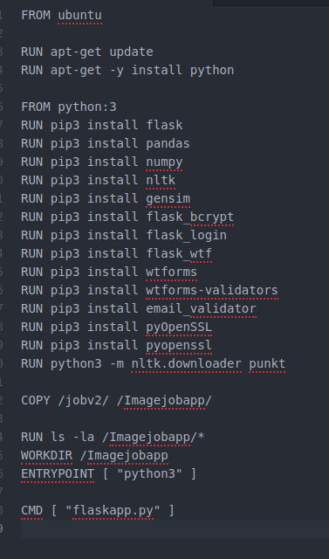

docker build -t myjobapp .

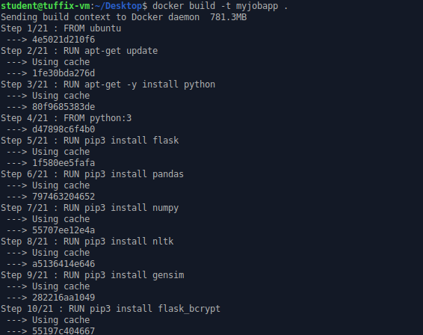

🡪Running the docker image

**docker run -i -p 5000:5000 myjobapp**

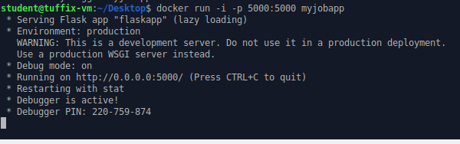

**🡪 Uploading image into docker hub**

**docker login**

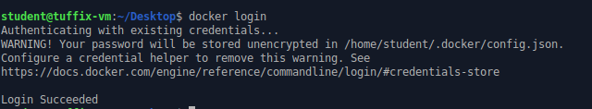

**Uploading into dockerhub**

My Repository name: **broy2808/jobapp.** Tag image name to the repository name and then do push.

**🡪 docker tag myjobapp broy2808/jobapp**

**🡪 docker push broy2808/jobapp**

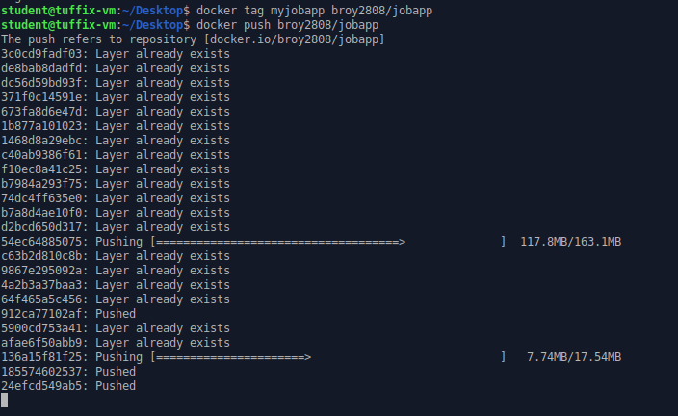

To use the image run below command:

**docker pull broy2808/jobapp**

**-------------------------------------------------------------------**

**docker save -o image broy2808/jobapp**

**----------------------------------------------------------------**

**\*\*\*\*\*\*\*\*\*\*\*\*\*\*\*\*\*\*\*\*\*\*\*\*\*EC2 -Flask website host\*\*\*\*\*\*\*\*\*\*\*\*\*\*\*\*\*\*\*\*\*\*\*\***

**EC2 instance:**

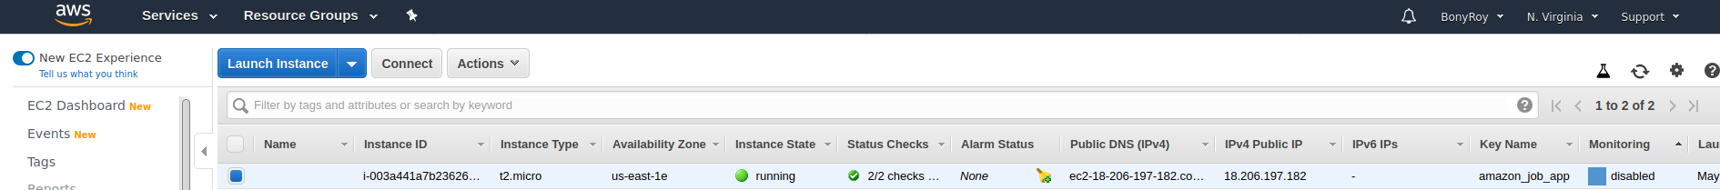

**Check the connect button after selecting the desired EC2 instance**

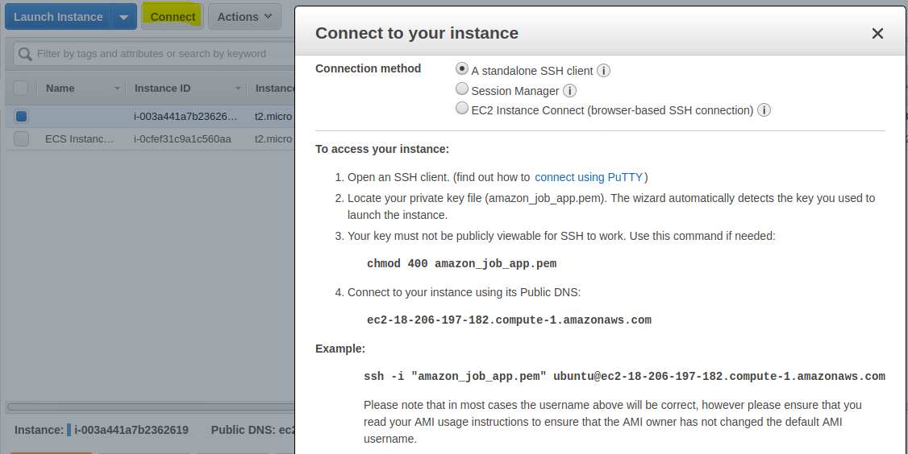

**Transfer project files from Own Linux machine to EC2 machine.**

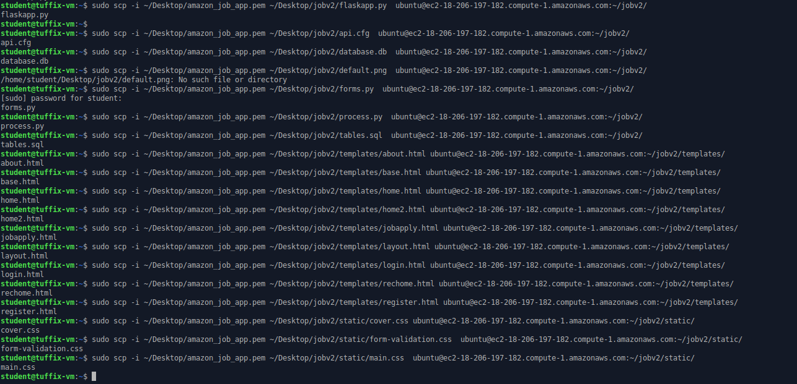

**Connect to the EC2 instance with connect information mentioned**

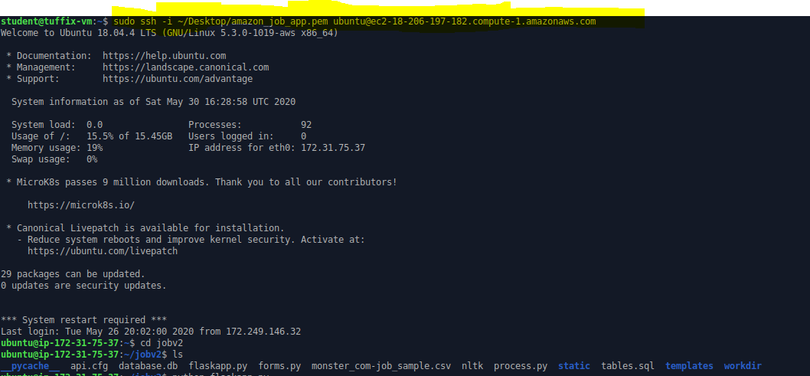

**Run the project**

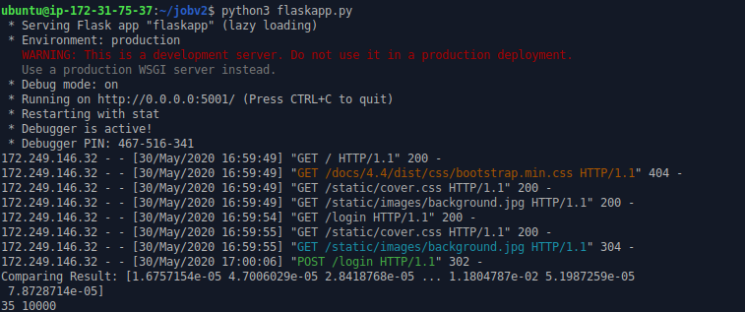

**Now go to the public ip in AWS EC2 portal:**



**Also, add the port number in the IP. I have set it up as 5001 while creating EC2 instance.**



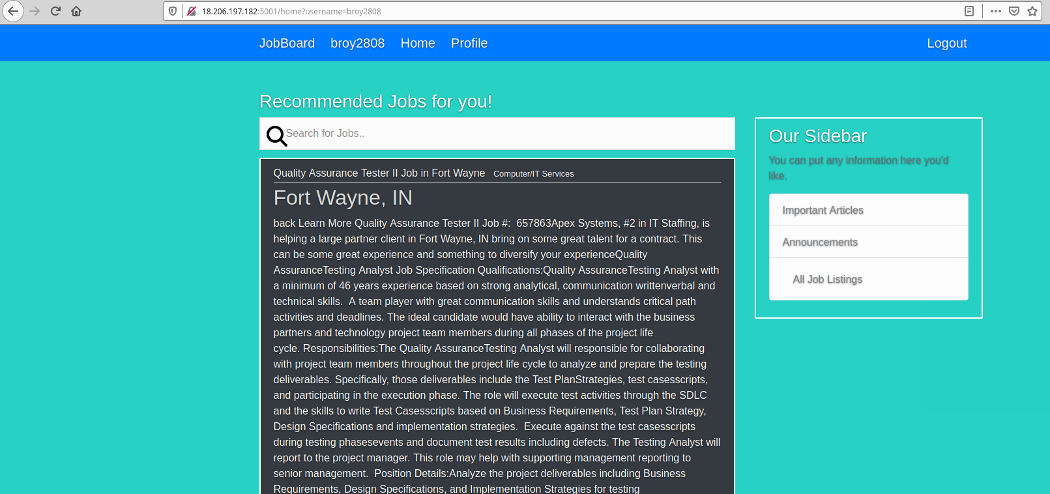

**Now my website is up and running on below address**

http://18.206.197.182:5001

But due to charges from EC2 currently instance is stopped.

**We need to run the ec2 instance in background to keep it running or use nginex server.**

**\*\*\*\*\*\*\*\*\*\*\*\*\*\*\*\*\*\*\*\*\*\*\*\*\*\*\*\*\*\*\*\*ECS/ECR AWS\*\*\*\*\*\*\*\*\*\*\*\*\*\*\*\*\*\*\*\*\*\*\*\*\*\*\***

**AWS ECS Cluster:**

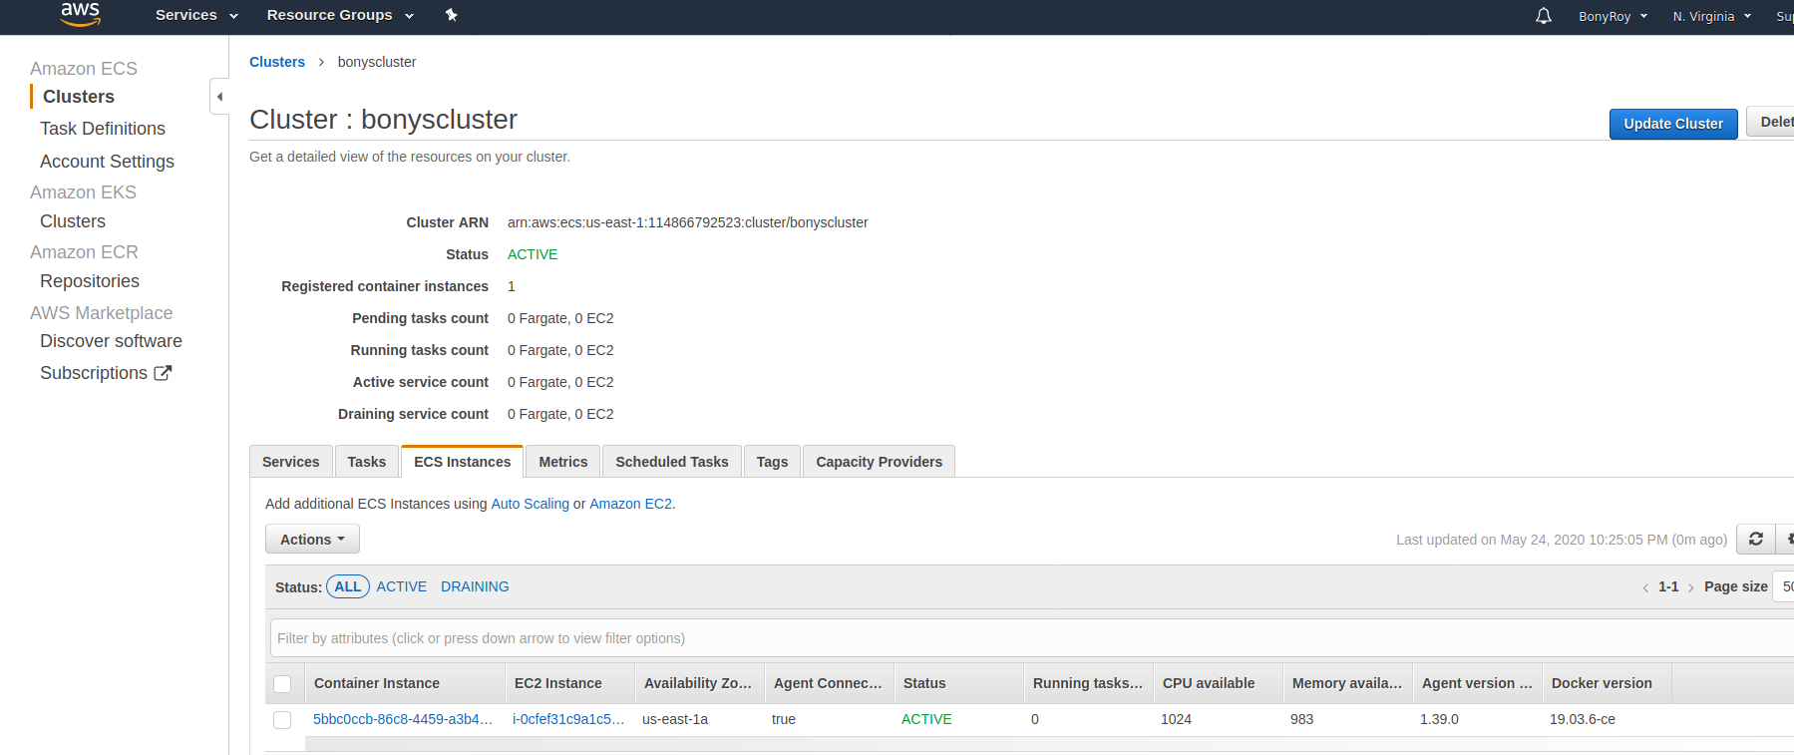

**AWS ECR registry:**

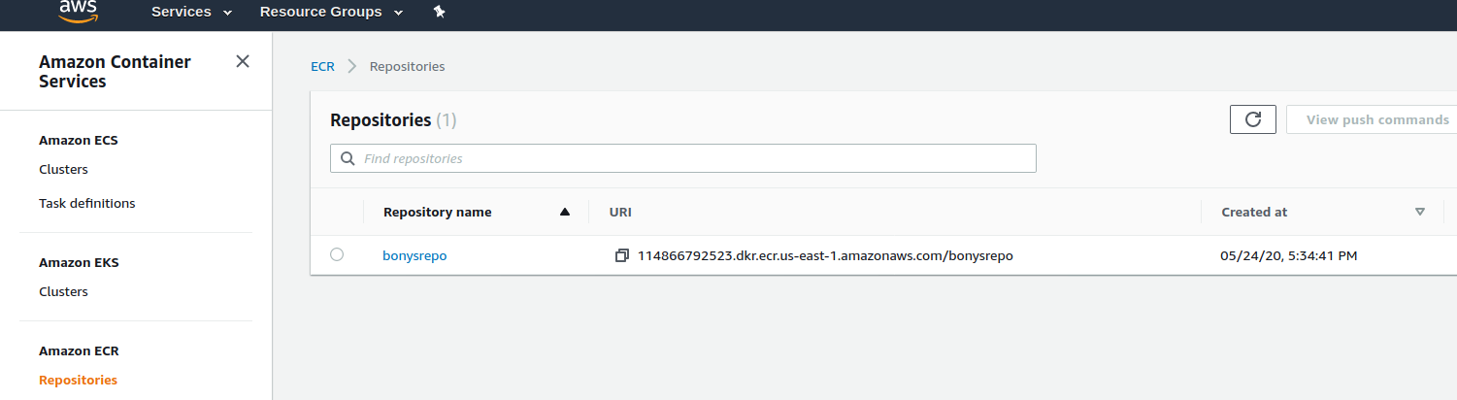

**AWS ECR through AWSCLI—**

**Login into ECR**

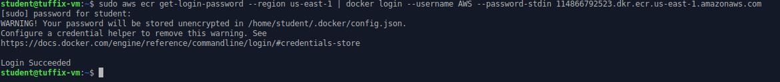

**Push image file into ECR: docker container**

**🡪 docker tag bonysrepo:latest 114866792523.dkr.ecr.us-east-1.amazonaws.com/bonysrepo:latest**

**🡪 docker push 114866792523.dkr.ecr.us-east-1.amazonaws.com/bonysrepo:latest**

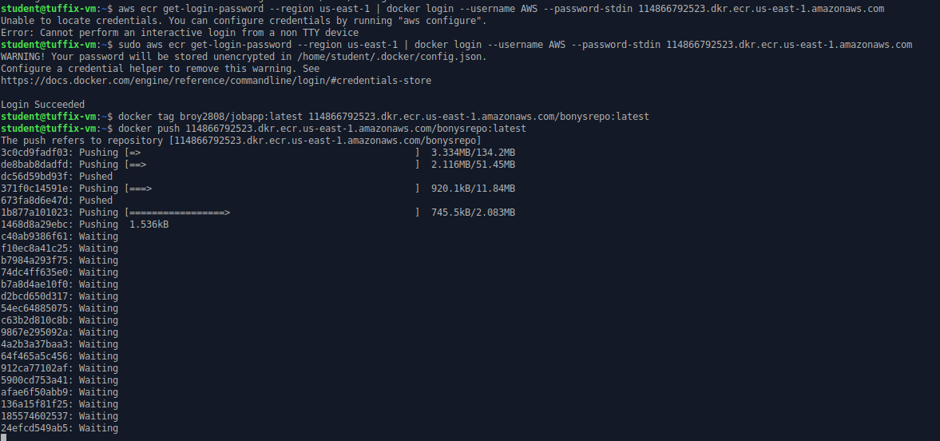

**Image in repository**

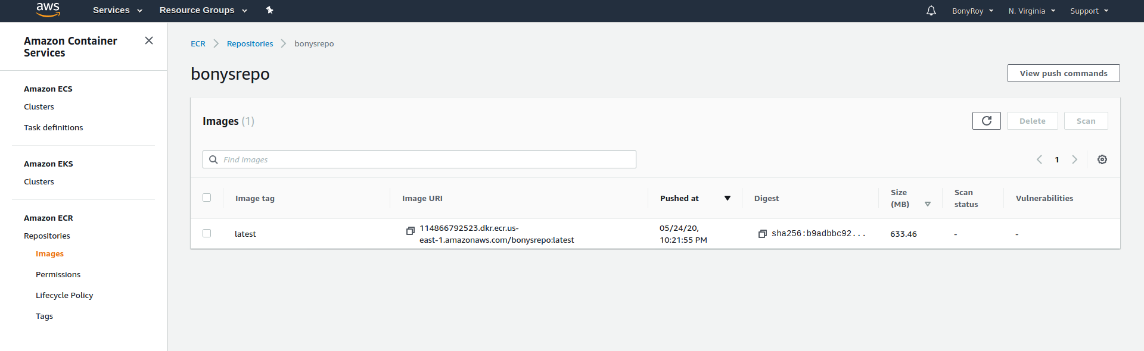

**Task definition:**

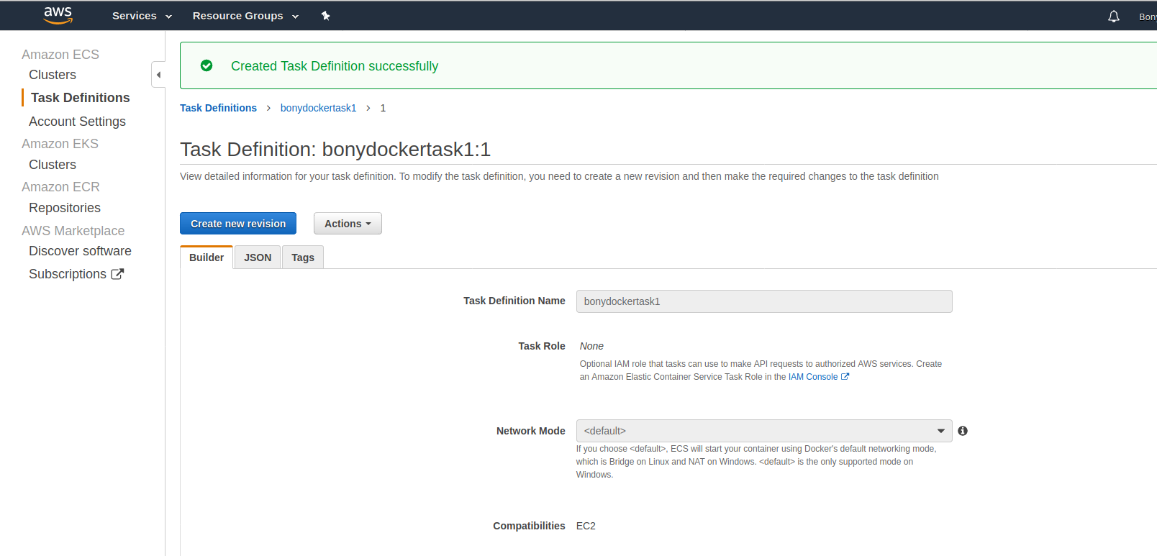

**Create service**

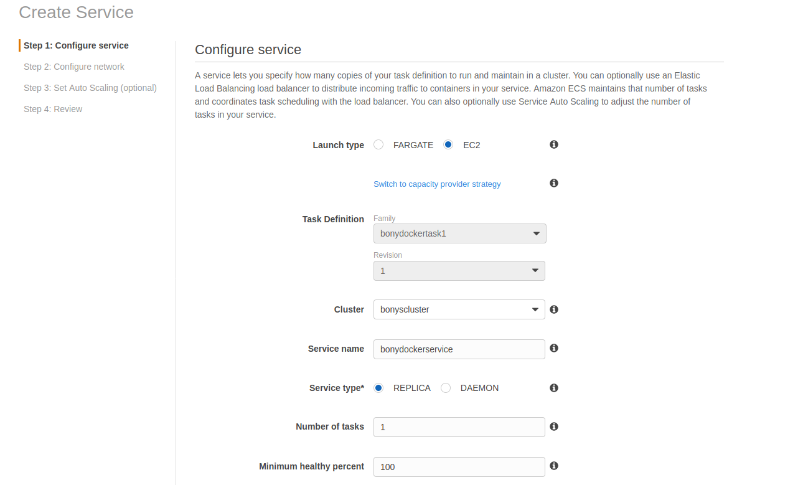

Docker service running.

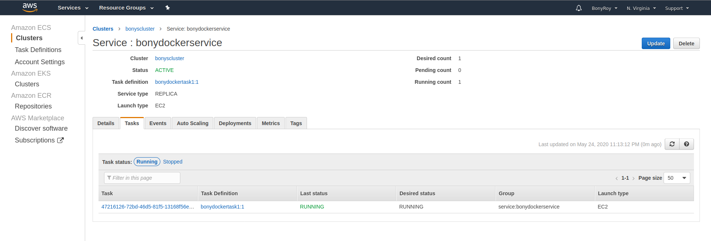

Go to task definition:

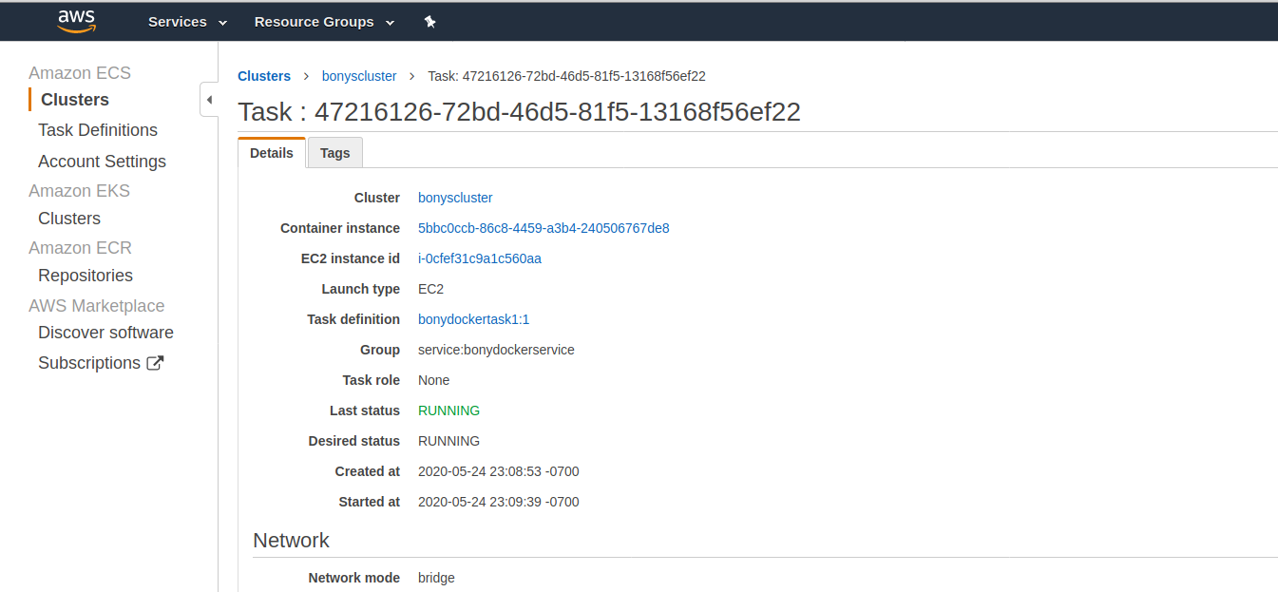



Link to website present.

Also, we can go via ec2 instance created via this.

<http://3.210.205.55:5000/>



Note: currently this link is not running as money is being charged for running this AWS service.

**************************ecs

ECS clusters

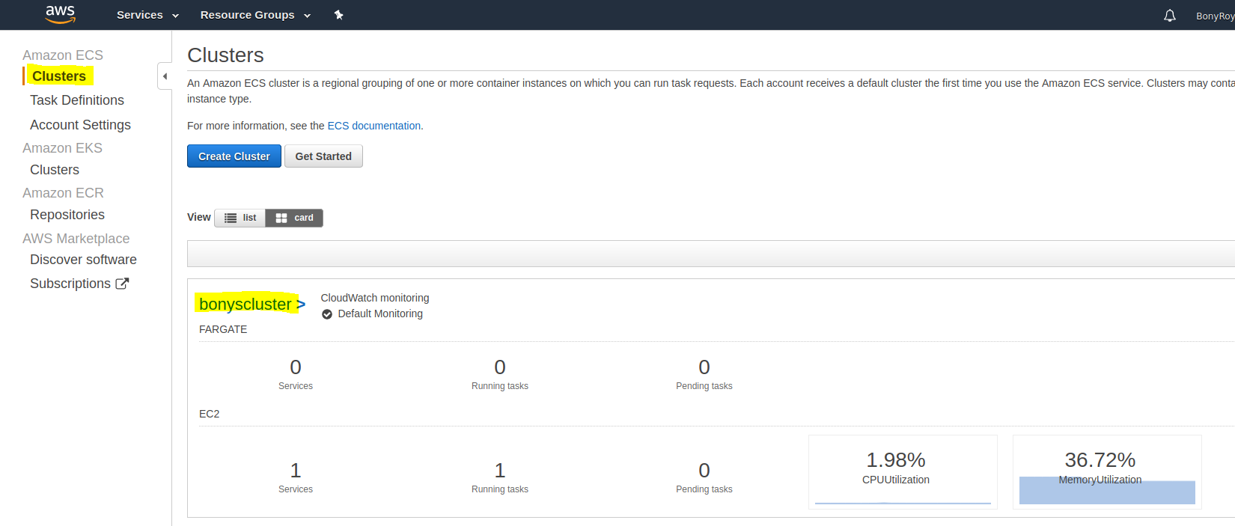

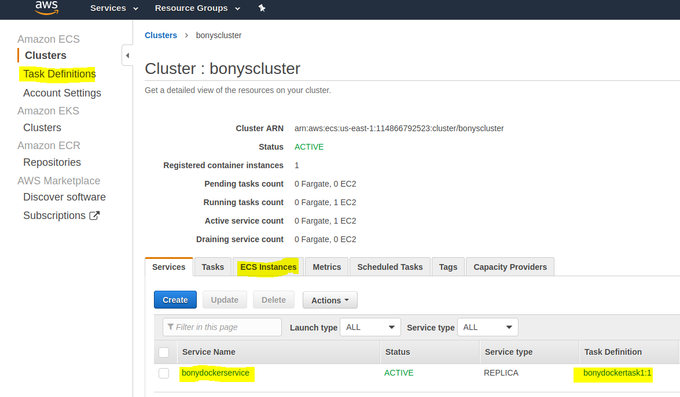

Task definition:

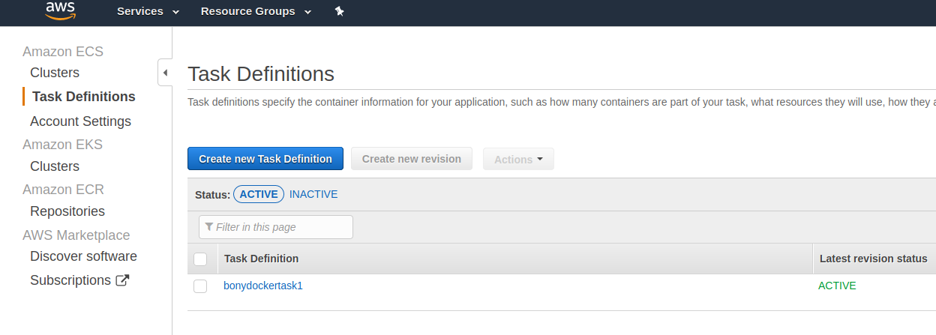

Amazon ECR

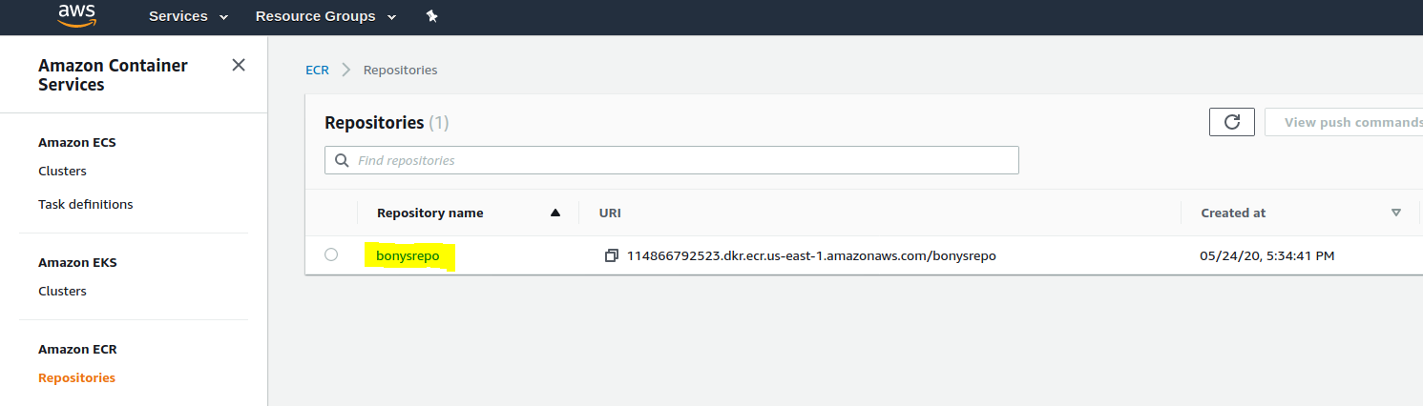

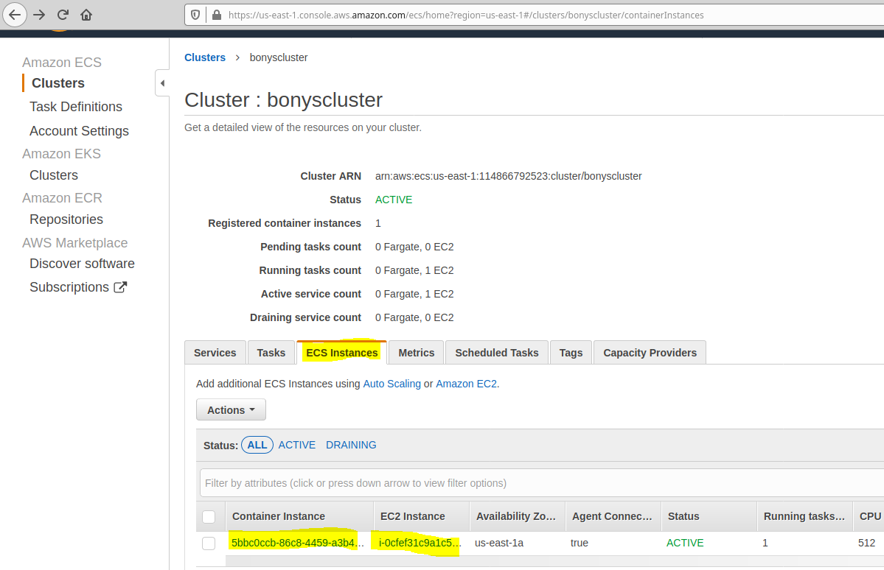

ECS container definition: tasks are tagged to the containers

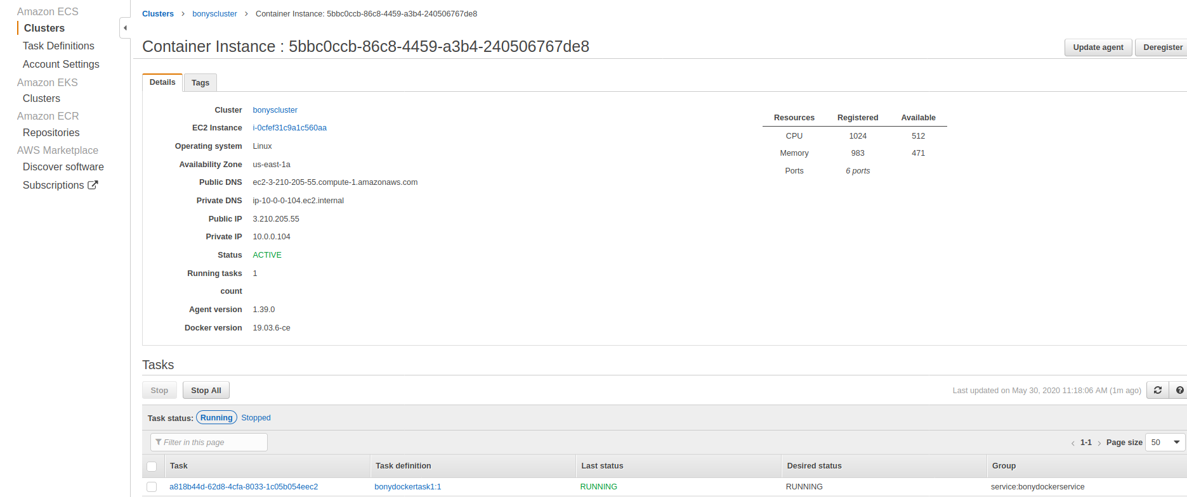

The task definition tagged to container. Public IP to the website mentioned and also image id.

